On the Border

Encuentro Project Newsletter
January 2023

FR. RAFAEL MEETS THE POPE
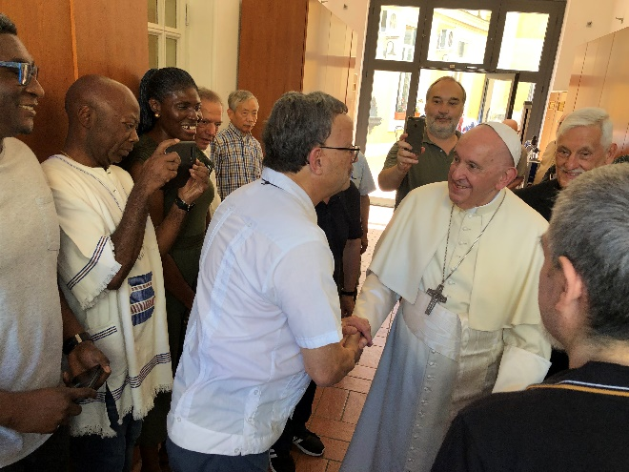
Fr. Rafael writes in July 2022: I had the opportunity to meet Pope Francis in a very unexpected way. A real Grace! Meeting Pope Francis was a strong motivation for traveling to come to Rome. When I introduced myself and mentioned that I was working in the El Paso border with Mexico, he quickly said, referring to migrant/refugee situation, "how many tragedies you must have seen there" "¡Cuántas cosas no habras visto!"
Sadly -- during the 6 seconds!! -- I could not mention that the name Encuentro for our project was inspired by his emphasis on the need for human encounters. Some of you might recall that my first idea was the name "Encuentro Project Papa Francisco", but, too long, though.

CURRENT SITUATION ON THE BORDER
With the end of the MPP (stay in Mexico) policy and the on again, off again end of Title 42, El Paso has seen a significant increase of migrants crossing the border. The fate of Title 42 will be determined by the Supreme Court. There are not sufficient shelters and many people have to stay at the airport, bus stations or in the streets until they can get tickets to go to their sponsors. Also, the migrants have been used as political pawns, being bused to other states with no advance warning. Now, we are seeing people who have not presented to Border Patrol and have no documents to travel.

The Diocese of El Paso and Annunciation House, as well as other non-profits and local government, have been trying to meet the needs of the migrants. Churches have recently opened their doors to migrants, including Sacred Heart parish which provides shelter in the former gym during the evenings. The Church has been in the news recently as it is where many of the migrants are gathering.

President Biden visited El Paso on January 8 but did not go downtown or see the full extent of the problem. Here is a report by Hope Border Project: https://mailchi.mp/hopeborder.org/fd-011023?e=2815e1023d

Here is more information about what is happening on the Border: https://www.cnn.com/2022/12/21/us/migrant-influx-us-border-what-it-looks-like/index.html

Texas Governor Abbott issued a directive to investigate non-profits who help immigrants. See article: https://www.ktsm.com/local/el-paso-news/governor-abbott-calls-for-investigation-into-el-paso-non-government-organizations/
Please reach out to your Congressional representatives to ask for a humanitarian immigration policy and share your experiences on the border.
REFLECTION FROM PARTICIPANT
Our weeklong journey came to an end: 10 persons from across the USA [clergy, laity] on a journey to encounter Christ along the southern US border with Mexico in El Paso, TX with the Maryknoll Fathers and Brother’s Mission Education group.
After lunch, about 20 minutes before I was to board, as I stood in line, I encountered a man, who was confused, lost, not knowing what was happening and what he had to do to get on the plane.
I sensed he is an immigrant with a travel certificate. He kept saying “New Jersey” and showed his boarding passes [El Paso to Chicago, Chicago to Newark] and he did not know what to do.
On the boarding line with me is another man, who tells me this man is from Turkey; he tries using Google translator to explain to our Turkish friend what to do since neither of us speak

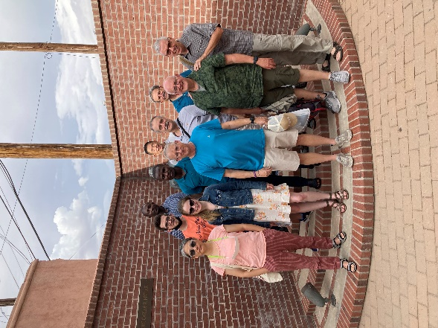
(Maryknoll Fathers and Brother’s Group)
Turkish. The young man tells us during conversation he travels to El Paso often for business. I suggest we help this immigrant.
We learned through the Encuentro Project that 68 different nationalities try to enter the USA through El Paso [including Turkish persons – for some reason, that was the only nationality I wrote in my journal three days before!].
We try to understand what the Turkish migrant is asking. He speaks into his phone, but the translator gets messed up. For example, we learn he wants to go to “Jersey”, but the translator keeps saying “Joker.” The Turkish man, from the gobbled translator asks us what ‘GATE’ do I go to in Newark? What ‘TRAIN’ in Chicago do I take at the airport to board a flight for Newark? My young businessman companion and myself keep trying to say “NO Train” and we “Don’t know the Gate yet.” The Turkish migrant is confused and does not seem to understand. In fact, at one point he called someone [his sponsor?], gave me his phone, and the person mentioned he was traveling to Newark. I said, I will help him as best I can along the journey.
I approached the gate agent, a young man new at the job, and explained that this man is Turkish, speaks NO English, wants to transfer to a flight to Newark, is lost and confused and can use help. I ask if he may board early with me [so I can show him his seat]. The agent says fine and that he will let agents in Chicago know about the man and they will help him.
The man and I board, and I take him to SEAT 19D, which had been my original seat before I was upgraded. I almost cry but keep it together [God, you are such a Joker!]. He does not understand so I hold up his boarding pass showing him the 19D little label above his row – he smiles and understands. He says ‘thanks.’ A few minutes later, as people board, I see he now has his hood up from his hoodie, to keep warm, trying to work the dials above his head – he is cold from the A/C. I get up and go over to him to shut off the air, and he smiles.
We are welcomed on the flight by a flight attendant, and I pull her aside to explain the situation for the man. The attendant tells me she will let agents in Chicago know about the needs of the man [to make his connection] and they will have a wheelchair for him so he can go from gate to gate with no problem.
Awesome! Well done! And I think, these agents are like the Border Patrol agents we met, who must keep to the policy and practices for which they are trained, but they can show compassion and mercy within the system!
Yes, there is a little more….
During the 3-hour flight I get to go to the bathroom and want to see how my Turkish friend was doing. He’s NOT sitting in 19D! Instead, he now was in 22D. I see the flight attendant and ask her what happened, and she tells me HE GAVE UP HIS SEAT so a young couple could sit together. The flight attendant offered him extra snacks and a drink [I gave him my comp crackers too, as I passed him; he had a 3+hr layover at O’Hare and we figured he would be hungry].
WOW, someone with so little gives what he can…. Hmmm, like the Gospel story of poor widow giving her coin from “her essence,” not from “her excess.”
EPILOGUE
When we landed in Chicago, I held off disembarking so I could accompany him off the plane. I gave him a bottle of water I took onto the plane, and a peanut butter sandwich I made for the flight but never ate – he will need these for his layover for some comfort. He took them.
We exit the plane, and I told the gate agent the situation. She was not informed of the man’s need but told me not to worry she will get that wheelchair. God takes over from here, finding others to help the Turkish traveler.
By Deacon Joe Ferrari

FINDING A NEW HOME
Negotiations with the owners of the Grandview property were unsuccessful and therefore, Encuentro Project is no longer associated with the house. So, at the present time, the Encuentro Project is using Airbnb’s to house the immersion trips. We hope to eventually have a permanent place to host our groups.
Since CDR closed, we added an opportunity for groups to prepare a meal and serve it at one of the shelters. This gives participants a chance to speak with and get to know the migrants more. Participants really enjoy this new experience.

CONTACT INFORMATION
Encuentro Project
602 S. Oregon St, El Paso, TX 79901
Email: encuentroproject@gmail.com
Newsletter Editor: Debbie Northern
Email: encuentroproject.assistant@gmail.com

2022 ENCUENTRO GROUPS
From August to December 2022, we had six groups. Next year looks to be busy with 16 groups already scheduled or looking to be scheduled! Here are some of the latest groups:

CHRISTOPHER COLUMBUS HIGH SCHOOL
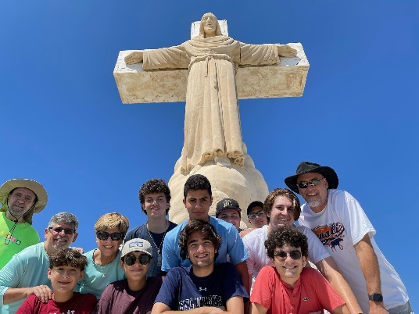

NOTRE DAME HIGH SCHOOL
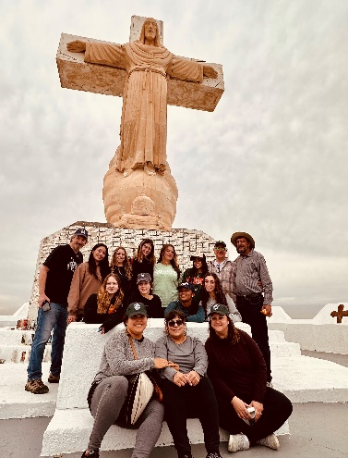

HOLY TRINITY PARISH

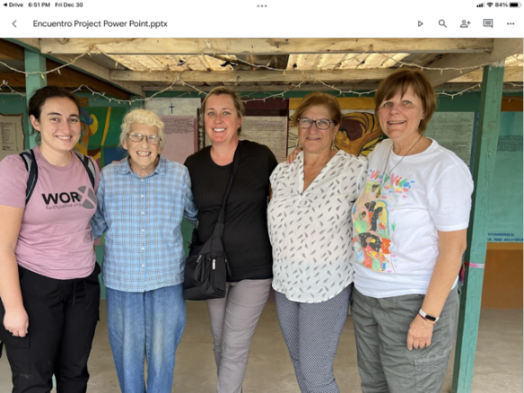

SISTERS OF SAINT JOSEPH
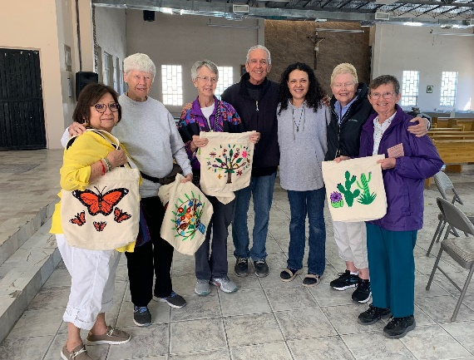

DETROIT MERCY COLLEGE SERVING DINNER
